
Department of BES-1
DATA STRUCTURES USING PYTHON
I/IV-B.Tech-(II Sem), Academic Year: 2024-2025
Session -18,19

Session 18

Circular Linked List

1 Session Outcomes:
- Student able to:
  - Understand what is a Circular linked list.
  - How to design a circular linked list.
  - How to create a node and how to link that node to the circular linked list.
  - Perform operations on CLL:

i. Insertion

ii. Deletion

iii. Display

iv. Search

2 What is Circular Linked List?

A Circular Queue is a queue where the last element is connected back to the first element, creating a circular structure. This allows for efficient usage of the queue's space, especially when elements are continuously enqueued and dequeued.

Circular Queue Operations:

Enqueue: Adds an element to the end of the queue.

Dequeue: Removes an element from the front of the queue.

Peek/Front: Retrieves the front element without removing it.

Is Full: Checks if the queue is full.

Is Empty: Checks if the queue is empty.

Applications

1. Memory Management (Buffer Management)

2. CPU Scheduling (Round-Robin Scheduling)

3. CPU Scheduling (Round-Robin Scheduling)

4. Networking and Packet Routing

5. Job Scheduling in Batch Systems

6. Call Center Management

We need to follow a few basic steps for each operation: Enqueue (add), Dequeue (remove), Peek (view front element), and Is Full / Is Empty (check the state of the queue).

Circular Queue Algorithm Steps:

Initialization:

We initialize an array of a fixed size to represent the queue.

We maintain two pointers: front (for removing elements) and rear (for adding elements).

Both pointers are initialized to 0.

Enqueue Operation:

If the queue is not full, we add the element at the position indicated by rear.

After adding the element, we move the rear pointer to the next position. If the rear reaches the end of the array, it wraps around to the beginning using modulo operation.

Dequeue Operation:

If the queue is not empty, we remove the element at the position indicated by front.

After removing the element, we move the front pointer to the next position. If it reaches the end of the array, it wraps around to the beginning using modulo.

Peek Operation:

The peek operation returns the element at the front without removing it, provided the queue is not empty.

Is Full / Is Empty Operations: Is Full: The queue is full if (rear + 1) % size == front. Is Empty: The queue is empty if front == rear.

- In single linked list, every node points to its next node in the sequence and the last node points NULL.
- But in circular linked list, every node points to its next node in the sequence but the last node points to the first node in the list.

Definition:A circular linked list is a sequence of elements in which every element has a link to its next element in the sequence and the last element has a link to the first element.
- That means circular linked list is similar to the single linked list except that the last node points to the first node in the list

Example
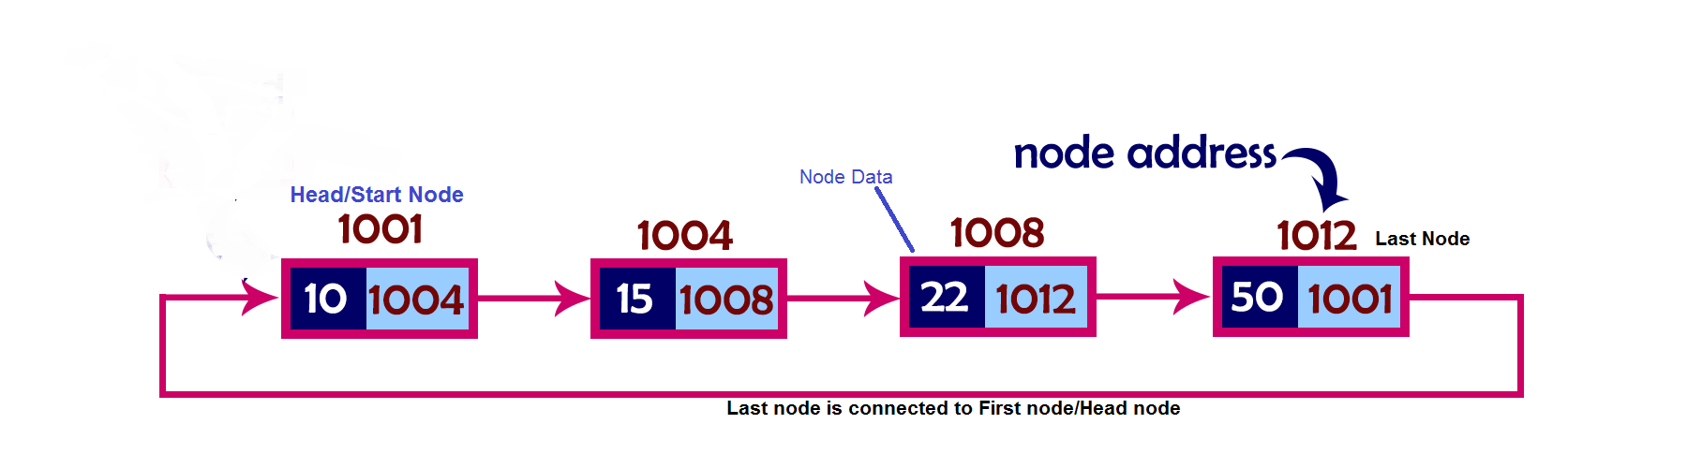

3 Types of CLL:

  - Circular Singly Linked list
  - Circular Doubly Linked list

1. Circular Singly Linked List
- Here, the address of the last node consists of the address of the first node.
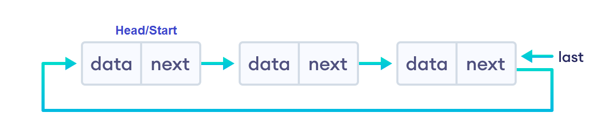
Circular Singly linked list
- Circular Doubly Linked List
- Here, in addition to the last node storing the address of the first node, the first node will also store the address of the last node.
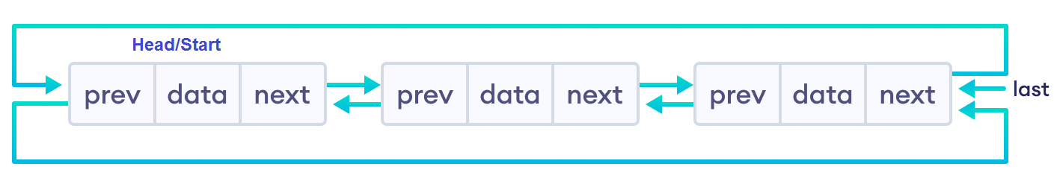
Circular Doubly linked list

2.3.4 Operations on CLL:
- In a circular linked list, we can perform the following operations...
- Insertion
- Deletion
- Display
- Search

Setup the CLL:

Before we implement those operations, first we need to setup empty list.
Perform the following steps to setup Empty CLL:.
Step 1 - Define a Node structure with two members/fields data and next
Step 2 - Define a Node pointer 'head' and set it to NULL.
Step 3 – Then perform the Operations one by one.
- The node is defined (represented) as:
struct Node
{
int data;
struct Node * next;
};
Struct Node head=NULL;
Insertion:
- Insertion At Beginning of the CLL
- Insertion At End of the CLL
- Insertion At Specific location in the CLL
Insertion At Beginning of the CLL:
- We can insert a new node at beginning(before head node) of the circular linked list.

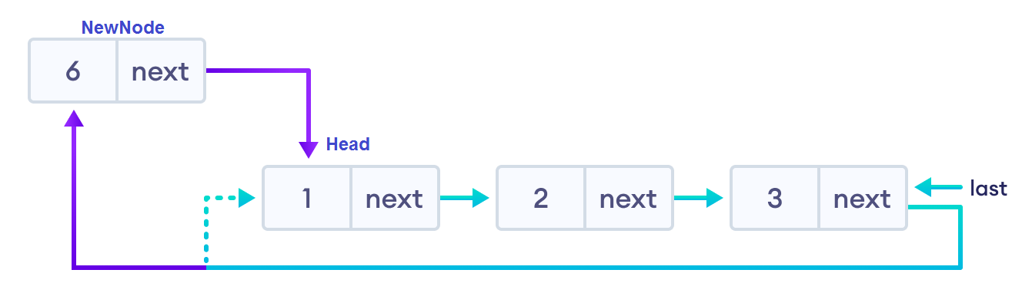

Algorithm:

1. Create a newNode by malloc().

2. Assign a value to the data field.

3. Check whether list is Empty (head == NULL)

3.1 If it is Empty then, set head = newNode and newNode→next = head .

4. If it is Not Empty then, define a Node pointer 'temp' and initialize

temp with 'head'.

4.1 move the 'temp' to its next node until it reaches to the last node (until 'temp → next == head').

4.2 Set 'newNode → next =head', 'head = newNode' and

'temp → next = head'.

Insertion At End of the CLL
- We to insert a new node at end of the circular linked list.

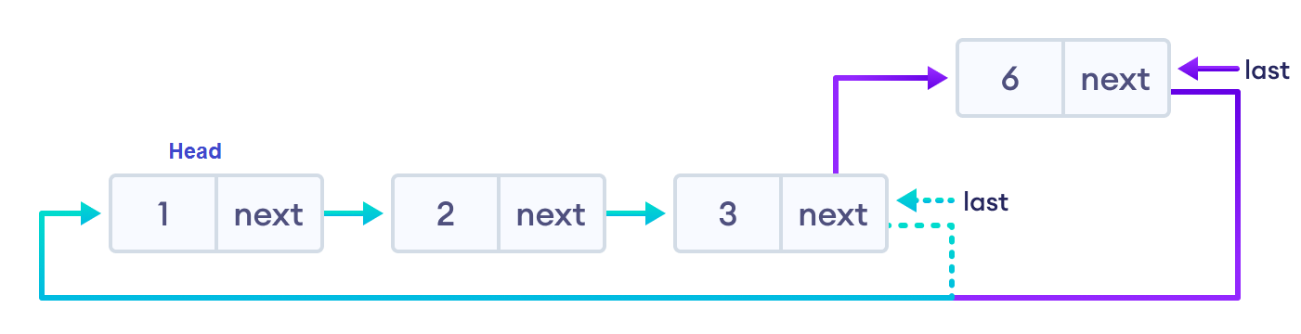

- Create a newNode with given value.
- Check whether list is Empty (head == NULL).

2.1 If it is Empty then, set head = newNode and newNode → next = head.

3. If it is Not Empty then, define a node pointer temp and initialize with head.

3.1 Move the temp to its next node until it reaches to the last node in the list (until temp → next == head).

3.2 Set temp → next = newNode and

newNode → next = head.

Inserting At Specific location in the list
- We need to insert a new node after a specific node in the circular linked list.

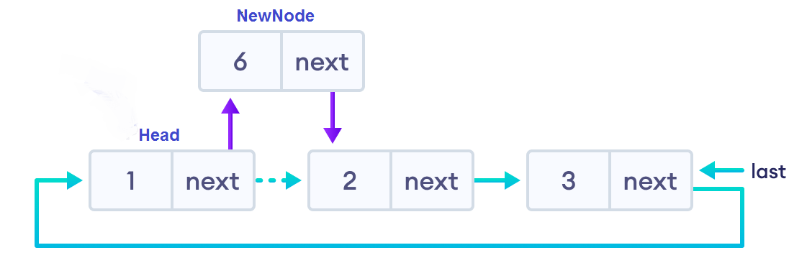

Algorithm:

1. Create a newNode with given value.

2. Check whether list is Empty (head == NULL) or not.

2.1 If it is Empty then, set head = newNode and

newNode → next = head.

4. If it is Not Empty then, define a node pointer temp and

initialize with head.

4.1 Move the temp to its next nodes (based on position or data value of the node).

4.2 If temp is reached to the last node then display'Given node is not found in the list! Insertion not possible!!!' and terminate.

4.3 Otherwise move the temp to next node.

4.4 If temp is reached to the exact node,

then check whether it is last node (temp → next == head) or not.

4.4.1 If temp is last node then

set temp → next = newNode and

newNode → next = head.

4.4.2 If temp is not last node then

setnewNode → next = temp → next and

temp → next = newNode.

Deletion of a node from CLL:
In a CLL, the deletion operation can be performed in three ways as follows:

i. Deleting from Beginning of the list

ii. Deleting from End of the list

iii. Deleting a Specific Node

- Deleting from Beginning of the list

We can delete a node from beginning of the CLL.

Algorithm:
- Check whether list is Empty (head == NULL)
- If it is Empty then,

2.1 Display' List is Empty! Deletion is not possible' and terminate.

3. If it is Not Empty then, define two Node pointers 'temp1' and 'temp2' and

initialize both 'temp1' and 'temp2' with head.

3.1 Check whether list is having only one node (temp1 → next == head)

3.1.1 If it is TRUE then

Set head = NULL and

deletetemp1 (Setting Empty list conditions)

3.1.2 If it is FALSE, then, move the temp1 until it reaches to the last node.

(untiltemp1 → next == head )

Then set head = temp2 → next,

temp1 → next = head and

delete mp2.

Deleting from End(Last node) of the CLL:
- We can delete a node from end of the CLL:

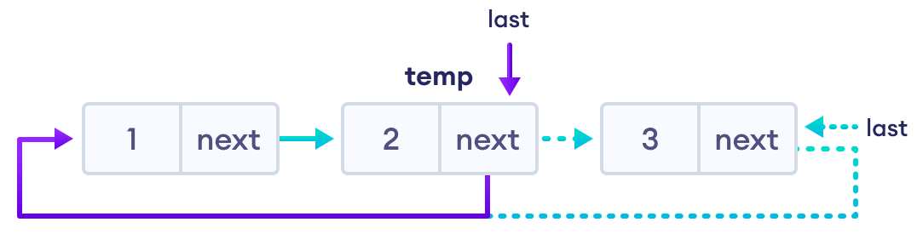

Algorithm:

1. Check whether list is Empty (head == NULL).
- If it is Empty then,

2.1 Display'List is Empty! Deletion is not possible' and terminate.

3. If it is Not Empty then, define two Node pointers 'temp1' and 'temp2' and

initialize 'temp1' with head.

3.1 Check whether list has only one Node (temp1 → next == head)

3.1.1 If it is TRUE. Then,

sethead = NULL and

deletetemp1,.and terminate.

3.1.2 If it is FALSE. Then,

Set 'temp2 = temp1 ' and move temp1 to its next node. Repeat the same until temp1 reaches to the last node in the list. (untiltemp1 → next == head)

Set temp2 → next = head and

deletetemp1.

Deleting a Specific Node from the list
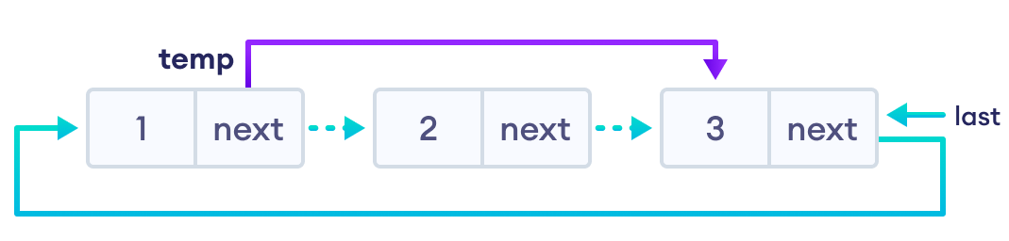
Algorithm:
1. Check whether list is Empty (head == NULL)
2. If it is Empty then,
2.1 Display'List is Empty! Deletion is not possible' and terminate.
3. If it is Not Empty then, define two Node pointers 'temp1' and 'temp2' and initialize 'temp1' with head.
3.1 Keep moving the temp1 until it reaches to the exact node to be deleted or to the last node.
And every time set 'temp2 = temp1' before moving the 'temp1' to its next node.
3.2 If it is reached to the last node then
Display 'Given node not found in the list! Deletion not possible!!!'.and terminate.
3.3 If it is reached to the exact node to be delete, then check whether list is having only one node (temp1 → next == head)
If list has only one node and that is the node to be deleted then sethead = NULL and
deletetemp1.
3.4 If list contains multiple nodes then check whether temp1 is the first node in the list
(temp1 == head).
3.4.1 If temp1 is the first node then
settemp2 = head and
keep moving temp2 to its next node until temp2 reaches to the last node. Then
sethead = head → next,
temp2 → next = head and
deletetemp1.
3.5 Iftemp1 is not first node then check whether it is last node in the list
(temp1 → next == head).
3.5.1 If temp1 is last node then
settemp2 → next = head and
deletetemp1.
3.6 Iftemp1 is not first node and not last node then
settemp2 → next = temp1 → next and
deletetemp1.

Displaying a circular Linked List:

Displaying the elements of a circular linked list means Printing all the elements of the CLL on the screen.

Algorithm:

Check whether list is Empty (head == NULL)

If it is Empty, then

2.1 Display 'List is Empty!' and terminate.

3. If it is Not Empty then, define a Node pointer 'temp' and initialize with head.

3.1 Keep displaying temp → data with an arrow (--->) until temp reaches to the last node.

3.2 Finally display temp → data with arrow pointing to head → data.

2.3.5 Implementation of Circular Linked List in Python

class Node:
def __init__(self, data):
self.data = data
self.next = None
class CircularLinkedList:
def __init__(self):
self.head = None

# Method to add a node at the end of the list
def append(self, data):
new_node = Node(data)
if not self.head:
# If the list is empty, the new node points to itself
self.head = new_node
new_node.next = self.head
else:
# Traverse to the last node and link it to the new node
temp = self.head
while temp.next != self.head:
temp = temp.next
temp.next = new_node
new_node.next = self.head

# Method to display the circular linked list
def display(self):
if not self.head:
print("List is empty.")
return
temp = self.head
while True:
print(temp.data, end=" -> ")
temp = temp.next
if temp == self.head:
break
print("... (head again)")

# Method to delete a node
def delete(self, key):
if not self.head:
print("List is empty.")
return
temp = self.head
prev = None

# If the node to be deleted is the head node
if temp.data == key:
if temp.next == self.head: # Only one node in the list
self.head = None
else:
prev = self.head
while prev.next != self.head:
prev = prev.next
prev.next = temp.next
self.head = temp.next
temp = None
return

# Search for the node to be deleted
while temp.data != key:
prev = temp
temp = temp.next
if temp == self.head:
print(f"Node with data {key} not found.")
return

# Unlink the node
prev.next = temp.next
temp = None

# Method to search for a node by its value
def search(self, key):
if not self.head:
print("List is empty.")
return False
temp = self.head
while True:
if temp.data == key:
return True
temp = temp.next
if temp == self.head:
break
return False

# Example usage
cll = CircularLinkedList()

# Adding nodes
cll.append(10)
cll.append(20)
cll.append(30)
cll.append(40)

# Display the circular linked list
print("Circular Linked List:")
cll.display()
# Search for a node
print("\nSearch for node with value 30:", "Found" if cll.search(30) else "Not Found")
# Delete a node
cll.delete(20)
# Display after deletion
print("\nCircular Linked List after deleting 20:")
cll.display()

# Try to delete a node that does not exist
cll.delete(50)
# Final display
print("\nFinal Circular Linked List:")
cll.display()

OUTPUT
Circular Linked List:
10 -> 20 -> 30 -> 40 -> ... (head again)

Search for node with value 30: Found

Circular Linked List after deleting 20:
10 -> 30 -> 40 -> ... (head again)
Node with data 50 not found.

Final Circular Linked List:
10 -> 30 -> 40 -> ... (head again)

2.3.5 Circular Linked List Complexity:

Circular Linked List Complexity | Time Complexity
Insertion Operation | O(1) or O(n)
Deletion Operation | O(1)

6 Advantages of Circular Linked Lists:

1. Efficient Circular Traversal
- Advantage: In a circular linked list, the last node points back to the first node, enabling easy traversal from any point. This is particularly useful in scenarios where you need to loop through a list repeatedly, without needing to restart from the head.
- Example Use Case: Implementing a round-robin scheduling algorithm where processes are executed in a cyclic manner.

2. No Need for NULL/None Handling
- Advantage: In a traditional singly linked list, the next pointer of the last node points to None (or NULL), marking the end of the list. In a circular linked list, the next pointer of the last node always points back to the first node, ensuring there is no need to check for None during traversal.
- Example Use Case: Circular traversal in applications like playlist management or implementing a circular queue.

3. Easy to Implement Circular Buffers
- Advantage: Circular linked lists are ideal for implementing circular buffers, where the buffer automatically wraps around when it reaches the end. This allows for efficient storage and retrieval of data in situations like streaming data or buffering video/audio.
- Example Use Case: Circular buffers for real-time data processing (like data streaming in embedded systems or networking).

4. Efficient Memory Usage in Specific Scenarios
- Advantage: Circular linked lists are especially beneficial when the list's size is dynamic and you don't need to maintain a fixed start or end. When resources are limited (e.g., in embedded systems), circular linked lists help by using memory efficiently and not requiring any extra sentinel or null nodes.
- Example Use Case: Real-time applications, like networking or hardware resource management, where the list size and contents may change dynamically.

5. Easy to Implement and Use with Head and Tail Pointers
- Advantage: Circular linked lists allow you to easily manage head and tail pointers. With a circular structure, operations like insertion and deletion at both ends of the list can be done in constant time (O(1)).
- Example Use Case: Implementing a deque (double-ended queue), where elements can be added or removed efficiently from both ends.

6. Suitable for Continuous Data Flow Applications
- Advantage: Circular linked lists are well-suited for applications where continuous, periodic, or cyclic data flow is required. Since traversal can seamlessly move from the end of the list back to the start, circular linked lists support this type of data flow naturally.
- Example Use Case: Games or simulations where players or entities continuously cycle through the game world, or in a buffer used in streaming protocols like TCP/IP.

7. Efficient for Implementation of "Next Available Element"
- Advantage: Circular linked lists provide a natural structure for maintaining "next available" elements in a cyclic fashion. This is useful in cases like managing resources in a pool where each resource is reused after being used.
- Example Use Case: Implementing a pool of workers (e.g., thread pool) where workers are reused after they finish their tasks.

7 Circular Linked List Applications

Applications:
- Round-Robin Scheduling: Managing processes in operating systems.
- Circular Buffers: For efficient, continuous data storage in real-time applications.
- Media Playlists: For looping through songs or videos.
- Josephus Problem: Solving the elimination problem in a circle.
- Circular Queue: Efficient queue management in situations like task scheduling or buffering.
- Memory Management: Efficient allocation and deallocation in memory pools.
- Real-Time Systems Simulation: Handling periodic events or tasks in real-time systems.
- Network Traffic Management: Efficient distribution of data packets or load balancing.
- Turn-Based Games: Managing turns in board or card games.
- Real-Time Event Processing: Handling continuous data or events in real-time systems.
Circular Linked Lists are an essential data structure in many systems requiring cyclic behaviors, periodic tasks, and efficient memory management. They allow for continuous, repeated operations in an elegant and efficient manner.

8 Disadvantages of Circular Queues:
- Fixed Size: The size is predetermined and cannot dynamically adjust, leading to potential overflow or underflow.
- Complex Implementation: Handling the wrap-around behavior and special cases like queue being full or empty can be tricky.
- Wasted Space: Reserved space for distinguishing full/empty states causes inefficient use of memory.
- Overflow and Underflow: Risk of data loss if overflow/underflow conditions are not handled properly.
- Inefficient Memory Utilization: Gaps between the front and rear pointers can result in wasted memory.
- No Dynamic Size Adjustment: Fixed size doesn’t allow for automatic growth or shrinkage based on data volume.
- Difficulty Modifying or Deleting Middle Elements: Removing or modifying elements from the middle is inefficient.
- Pointer Management Complexity: More complex in languages without automatic memory management

9 The time complexity of operations in a Circular Queue is very efficient due to its cyclic nature. The time complexities for the common operations are as follows:

1. Enqueue (Insertion)
- Time Complexity: O(1)
- Explanation: In a circular queue, inserting an element at the rear is done in constant time. When you insert an element, you simply move the rear pointer to the next position. The operation does not require shifting elements, making it very efficient.
- Example: Inserting an element at the end of the queue, whether the queue is near full or has plenty of space, takes constant time.

2. Dequeue (Deletion)
- Time Complexity: O(1)
- Explanation: Deleting an element from the front of the queue is also done in constant time. When an element is dequeued, you simply move the front pointer to the next position (which can also wrap around if necessary). This operation also does not require shifting elements, making it efficient.
- Example: Removing an element from the front of the queue is done in constant time, regardless of the number of elements in the queue.

3. Front (Accessing Front Element)
- Time Complexity: O(1)
- Explanation: Accessing the element at the front of the circular queue is done in constant time because the front pointer directly points to the element at the front of the queue. There's no need for traversal.
- Example: Checking the value of the front element does not require iteration through the queue and is done in constant time.

4. Rear (Accessing Rear Element)
- Time Complexity: O(1)
- Explanation: Accessing the element at the rear of the queue is done in constant time, as the rear pointer directly points to the last element in the queue.
- Example: Checking the value of the rear element can be done immediately without any need for traversal.

5. Check if Queue is Empty
- Time Complexity: O(1)
- Explanation: Checking whether the queue is empty can be done in constant time. This is determined by comparing the front and rear pointers (or using a specific condition to track the empty state).
- Example: If the front pointer is equal to the rear pointer, the queue is empty, which can be checked in constant time.

6. Check if Queue is Full
- Time Complexity: O(1)
- Explanation: Similarly, checking whether the queue is full can be done in constant time. This is typically determined by checking if the next position of the rear pointer equals the front pointer, indicating the queue has no space for further elements.
- Example: If (rear + 1) % size == front, the queue is full.

7. Resizing the Circular Queue (If Applicable)
- Time Complexity: O(n)
- Explanation: If the circular queue is implemented with a fixed-size array and needs resizing (e.g., doubling the size when the queue is full), this operation will require moving all the elements to a new array. This operation is O(n), where n is the number of elements in the queue.
- Example: Resizing the queue is usually not needed for standard circular queue operations but may be necessary if dynamic resizing is supported.

Summary of Time Complexities:
- Enqueue: O(1)
- Dequeue: O(1)
- Front: O(1)
- Rear: O(1)
- Check if Empty: O(1)
- Check if Full: O(1)
- Resizing (if applicable): O(n)

SESSION 19
PRIORITY QUEUE MATERIAL

Definition: Priority queue is an abstract data type that is similar to a queue and every element some priority value associated with it .
The priority of the elements in a priority queue determines the order in which elements are served. If any case the elements have same priority they are served as their ordering in the queue.

PROPERTIES OF PRIORITY QUEUE
A priority queue is an extension of the queue with the below properties
  - Every element has a priority associated with it.
  - An element high priority is dequeued before an element with low priority.
  - If two elements have the priority they are served according to the their order in the queue.

- Algorithm for implementing Priority Queue using Binary Heap

Step1: Create a function heapify() to heapify the elements in the Binary Tree if any changes are made.
Step2: Find the largest among root, left child, and right child, then recursively call the same function until the root element matches the largest element.
Step3: Create a function insert() to insert an element into the tree, which takes an array and the number which is to be inserted as input.
Step 4: If the size of the array is zero, then this number will be the root, else append the number and call the heapify function recursively to heapify the elements.
Step5: Create a function deleteNode() that deletes the selected element from the tree
Step 6: Delete the element and again heapify the elements recursively.
Step 7: Insert elements into an empty array using the insert() function then try deleting an element from the tree.
Let us consider a sample priority queue , an element with a maximum ascii value will have the highest priority.
The elements with higher priority are served first.
Initial queue = { }

Operation | Return value | Queue content
Insert (c) |  | C
Inset (O) |  | C O
Inset (D) |  | C O D
Remove max | O | C D
Insert (I) |  | C D I
Inset(N) |  | C D I N
Remove Max | N | C D I
Insert(G) |  | C D I G

PROCESS OF ASSIGNING ELEMENTS IN A PRIORITY QUEUE BASED ON THE PRIORITY

- In priority queue generally the value of the element is considered for assigning the priority for example the element with the highest value is assigned with highest priority and the element with the lowest value is assigned with the lowest priority.
- The reverse case can also be used i.e, the element with the lowest value can be assigned with the highest priority.
- Also the priority can be assigned according to our needs.

PRIORITY QUEUE SUPPORTS THE FOLLOWING OPERATIONS

- Insertion in a priority queue
- Deletion in a priority queue
- Peek in a priority queue

Extend left(iterable): Adds all elements from an iterable to the left end of the deque (note that the iterable is added in reverse order).
Time Complexity: O(k), where k is the number of elements in the iterable.
rotate(n): Rotates the deque by nnn steps. Positive n rotates to the right, and negative nnn rotates to the left.
Time Complexity: O(k), where k is the number of elements in the deque.
Conclusion:
Most operations on a deque, such as adding or removing elements from either end, have a time complexity of O(1). However, some operations like extend and rotate that involve adding or rearranging multiple elements can have time complexity of O(k), where k is the number of elements involved.

